**Assignment_8**

**Grant, Revoke.**

Create user by name sunbeam in root login

Note: To solve below queries use ‘classwork’ database.

1. Give UPDATE privilages on BOOKS table to sunbeam.

**grant update on classwork.books to sunbeam;**



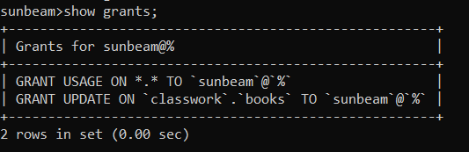

1. Give sunbeam the right to SELECT the data from BOOKS,EMP,DEPT tables.

**grant select on classwork.books to sunbeam;**



**grant select on classwork.dept to sunbeam;**



**grant select on classwork.emp to sunbeam;**



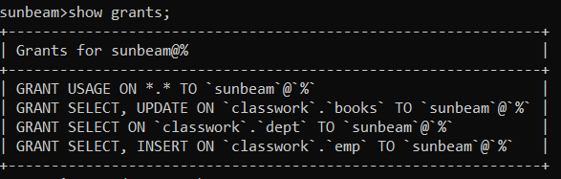

1. Give INSERT privilage on EMP table to sunbeam.

**grant insert on classwork.emp to sunbeam;**



1. Give DELETE privileges on DEPT table to sunbeam .

**revoke all privileges on classwork.dept from sunbeam;**



1. Take the UPDATE privilege on BOOKS table away from sunbeam.

**revoke update on classwork.books from sunbeam;**



1. Take the INSERT privilege on EMP table away from sunbeam.

**revoke insert on classwork.emp from sunbeam;**



1. Take the DELETE privilege on DEPT table away from sunbeam.

**revoke delete on classwork.dept from sunbeam;**



1. Take the SELECT privilege on BOOKS,EMP,DEPT tables away from sunbeam.

**revoke select on classmate.books from sunbeam;**

**revoke select on classmate.emp from sunbeam;**

**revoke select on classmate.dept from sunbeam;**